**Oracle Administration Services**

Oracle DG Broker Configuration

Submitted to



**By**



CIS, Wipro Limited

Document Details

|  |  |
| --- | --- |
| Project Name | Innogy SE |
| Account | CIS |
| IT Component/Application Title | DG broker configuration |
| Current Version | 1.2 |
| List of Contributors | JitenKumar Pansara, Sreya Puthukudy |
| Customer Contact Information |  |

Version History

(All revisions made to this document must be listed in chronological order. All revisions must be approved. Review and Approval can be done by an internal source or by the customer)

|  |  |  |  |  |  |
| --- | --- | --- | --- | --- | --- |
| Version | Date of Revision | Description | Author | Reviewed By | Approved By |
| 1.0 | 16-11-2016 | Intial Draft | JitenKumar pansara | Balaji Ankalle | Mahesh keshatwar |
| 1.1 | **22-01-2017** | **Document Completed** | JitenKumar pansara | Balaji Ankalle | Mahesh keshatwar |
| 1.2 | **20-12-2018** | Updated the content | Sreya Puthukudy | JitenKumar Pansara | Santosh Badiger |

Document Distribution List

|  |  |  |
| --- | --- | --- |
| **S.No** | **Name and Company** | **Purpose** |
| **1** | RWEIT-ORACLEDBA | **This document is regarding DG broker configuration** |
| **2** |  |  |

**Steps:**

(1)Create physical standby database. It should be in sync with Primary database.

(2) Set the DG_BROKER_START Initialization Parameter

select name,open_mode,log_mode,database_role from v$database;

show parameter dg_broker_start

ALTER SYSTEM SET DG_BROKER_START=TRUE;

show parameter dg_broker_start

show parameter dg_broker_config

select protection_mode from v$database;

select max(sequence#) from v$log_history;

archive log list

Primary:-

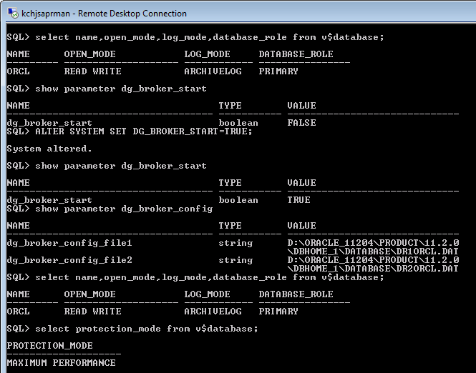

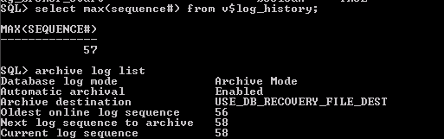

Standby:-

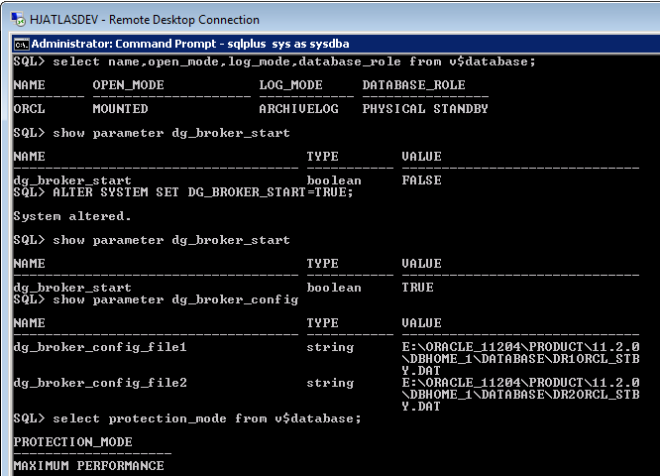

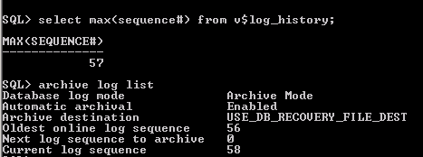

(3) Edit the listener.ora on both nodes to add a static entry for DGMGRL

**Primary:-**

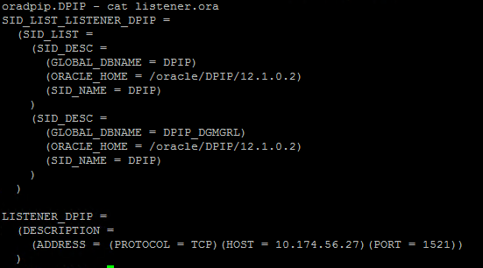

**Standby:-**

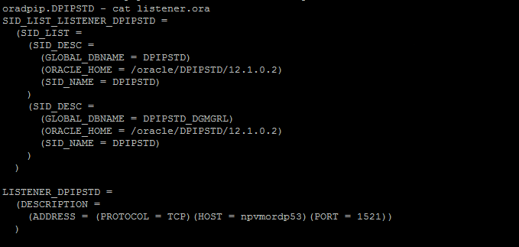

Note: The value for the GLOBAL_DBNAME should be <db_unique_name>_DGMGRL.<db_domain>.

SHOW PARAMETER SERVICES_NAMES:- “service_names” should match with “service” in tnsnames.ora

Set local listener if port is other than 1521.(On both the servers).

Primary:-

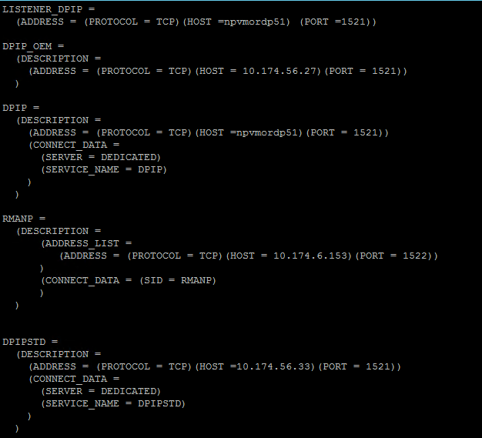

Standby:-

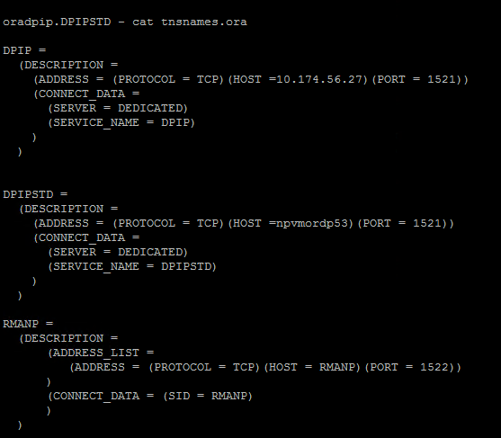

(4) Restart listener and check whether dgmgrl service is appeared or not.

Primary:-

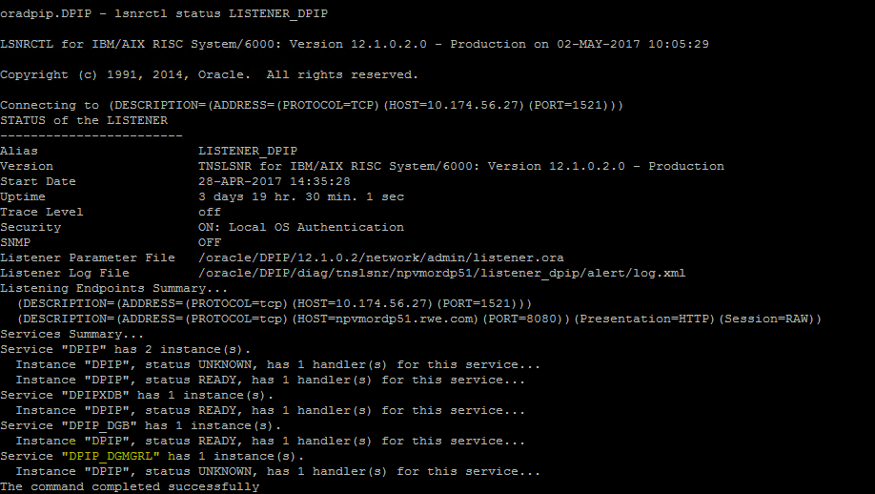

Standby:

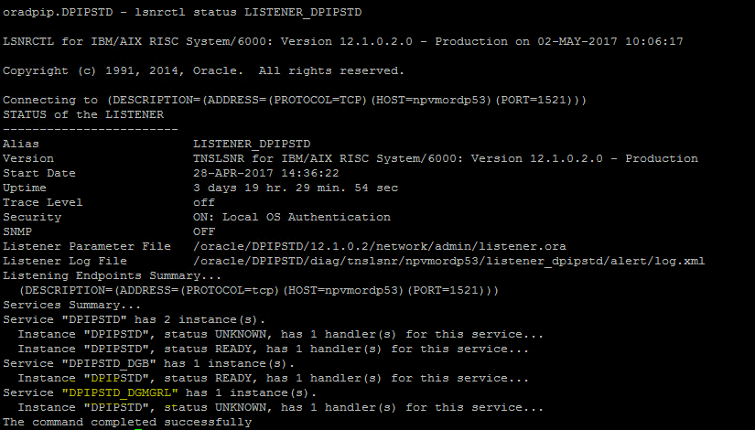

**(5)** Creating the Broker Configuration

|  |  |
| --- | --- |
| **1.** | Invoke DGMGRL and connect to your primary database. Enter your password for SYS      CONFIGURATION STATUS SHOULD BE “SUCCESS”.  SHOW DATABASE orcl  SHOW DATABASE orcl_stby  DATABASE STATUS SHOULD BE “SUCCESS”. |

(6)Testing the Broker with a Switchover

CHECK THE DATABASE PROPERTIES

SHOW DATABASE VERBOSE orcl

SHOW DATABASE VERBOSE orcl_stby

CHECK STATICCONNECTIDENTIFIER

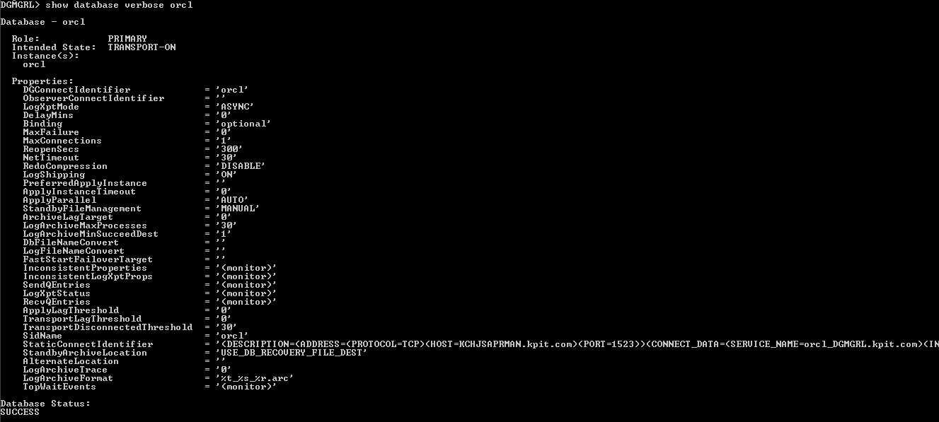

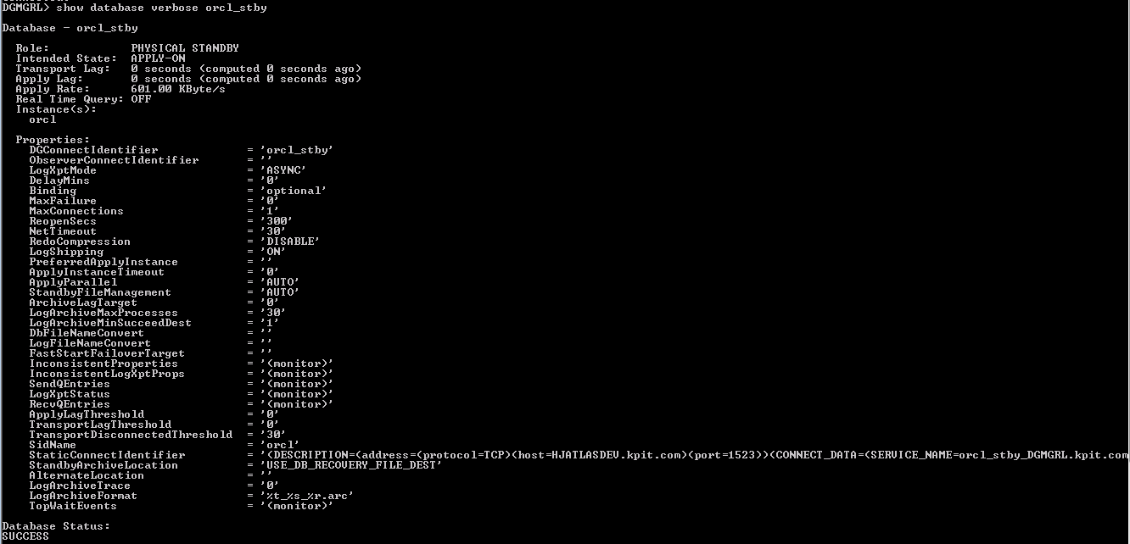

Check StaticConnectIdentifier very carefully. The network details should be proper.

Switchover:-

Primary site:-

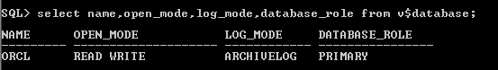

Invoke dgmgrl and connect to sys(Primary DB)

To perform switchover, “switchover to <standby_db_unique_name>)”

Check the status after switchover on both sites.

Primary and standby roles are switched now.

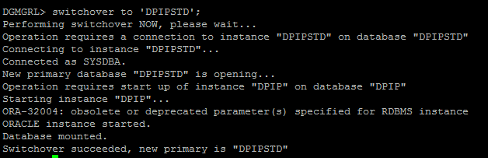

Standby site:-

Switch logs on new Primary (old standby) and check the sync between the two

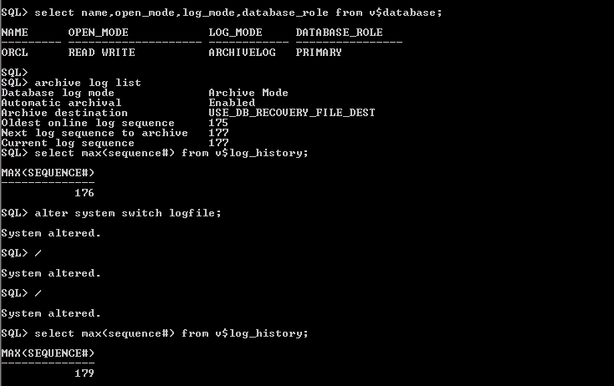

Primary site:-

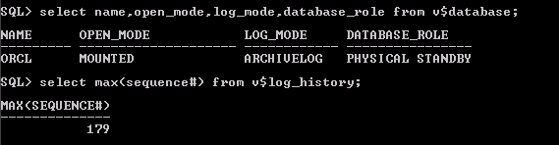

Switch back:-

Primary site:

Invoke dgmgrl and connect to sys(old Primary DB)

To perform switchover, “switchover to <primary_db_unique_name>)”

Check the status after switchover on both sites.

Primary and standby roles are switched now.

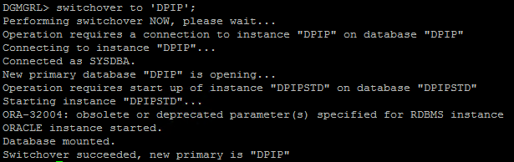

Standby Site:-

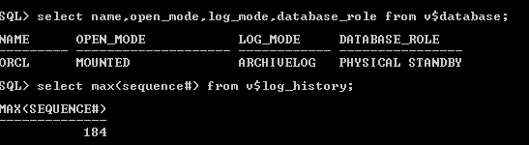

Primary site:-

Switch the logs and check sync

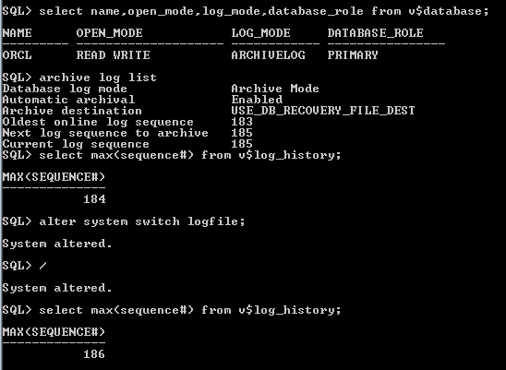

Standby Site:-

